Home Visit Policy
Table of Contents
Introduction 1
• Purpose 1
• Scope 2
• Relevant legislation and guidance 2
Home Visit Expectations 2
• For All Nursery Staff, Students and Volunteers 2
• For Parents and Carers 2
• Compliance and Disciplinary Measures 2
Processes and Procedures 2
Safety and Confidentiality 3
Staff Training 3
Communication with Parents 4
Policy management and review 4

Introduction
- Purpose
The purpose of this Home Visit Policy is to ensure the safety and effectiveness of home visits conducted by The Little Bumblebee Nursery staff. Home visits are intended to build strong relationships with families, assess the child's home environment, and provide personalized support to parents and carers. This policy outlines the necessary procedures and responsibilities to ensure that home visits are conducted professionally, safely, and with respect for the family's privacy.

- Scope
This policy applies to all staff members at The Little Bumblebee Nursery who are involved in conducting home visits. It also provides guidelines for parents and carers regarding the home visit process.
- Relevant legislation and guidance
- Children Act 1989 and 2004
- Data Protection Act 2018
- Health and Safety at Work Act 1974
- Safeguarding Vulnerable Groups Act 2006
- Early Years Foundation Stage (EYFS) Statutory Framework

Home Visit Expectations
- For All Nursery Staff, Students and Volunteers
- Ensure all home visits are pre-arranged and agreed upon with parents or carers.
- Conduct home visits in pairs to ensure safety and accountability.
- Respect the family's privacy and cultural practices during the visit.
- Always use professional and respectful language.
- Carry identification and any necessary documentation during the visit.
- Provide feedback and follow-up support as needed.

- For Parents and Carers
- Agree on a suitable date and time for the home visit.
- Ensure a responsible adult is present during the home visit.
- Provide a safe and appropriate environment for the visit.
- Communicate any specific needs or concerns prior to the visit.
- Engage openly with nursery staff during the visit.
- Compliance and Disciplinary Measures
Non-compliance with the home visit policy may result in disciplinary action for staff, which can include retraining, written warnings, or termination of employment. Parents and carers who do not adhere to the guidelines may have future home visits reconsidered or canceled.

Processes and Procedures

Pre-Visit Procedures
- Scheduling the Visit:
  - Arrange the visit with the family at a mutually convenient time.
  - Confirm the visit in writing, detailing the purpose and expected duration.
  - Ensure the family understands the visit's objectives and what to expect.
- Preparation:
  - Review the child’s records and any relevant information prior to the visit.
  - Plan the visit itinerary and objectives.
  - Prepare any materials or resources needed for the visit.

During the Visit
- Arrival:
  - Arrive on time and introduce yourselves with identification.
  - Explain the purpose of the visit clearly and concisely.
  - Seek permission before entering different areas of the home.
- Conducting the Visit:
  - Observe and interact with the child in their home environment.
  - Discuss any concerns or questions the parents may have.
  - Provide guidance and support tailored to the family’s needs.
  - Document any significant observations or information.
- Safety and Professionalism:
  - Maintain professional boundaries at all times.
  - Ensure both staff members stay together during the visit.
  - Leave immediately if you feel unsafe or uncomfortable and report any incidents to the setting manager.

Post-Visit Procedures
- Reporting:
  - Complete a home visit report detailing observations and interactions.
  - Share relevant information with the nursery team while maintaining confidentiality.
  - Follow up on any actions or recommendations made during the visit.
- Feedback:
  - Provide feedback to the family regarding the visit’s outcomes.
  - Offer additional support or resources as needed.
  - Schedule any necessary follow-up visits or meetings.

Safety and Confidentiality

Safety Precautions
- Conduct a risk assessment prior to the visit if there are any known concerns.
- Ensure mobile phones are charged and accessible during the visit.
- Inform a designated contact person at the nursery of the visit details and expected duration.

Confidentiality
- Respect the family's privacy and confidentiality at all times.
- Ensure that any information gathered during the visit is stored securely and shared only with relevant nursery staff.

Staff Training
All staff involved in home visits will receive training on:
- The purpose and objectives of home visits.
- Effective communication and engagement with families.
- Safeguarding and risk assessment procedures.
- Maintaining professionalism and confidentiality.

Communication with Parents
The nursery will engage with parents and carers to ensure they understand the home visit process through:
- Providing information about the purpose and benefits of home visits.
- Discussing any concerns or questions parents may have.
- Offering support and resources to help prepare for the visit.

Policy management and review
- The Little Bumblebee will review this policy annually. In cases of relevant legal or procedural changes, we will review this policy accordingly. The policy should be made available on the Nursery website, with paper copies provided by the Nursery upon request.
- The policy should be approved, signed and dated and the date for review noted.
- The policy should be provided to and followed by all staff and volunteers.

This policy statement was adopted on 01/05/2024.
Reviewed By: Mojdeh Najafpoor | Date: 01/05/2024
Signed:  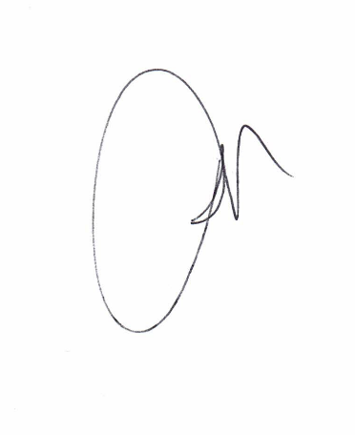 | Next Review Date: 01/05/2025

