Medication Policy
Table of Contents
Introduction 2
• Scope 2
Medication Expectations 2
• For All Parents, Staff, Students and Volunteers 2
Medication Processes and Procedures 2
• Documentation: 2
• Administration Procedures: 3
• Storage and Accessibility: 4
Policy management and review 4

Introduction
At The Little Bumblebee Nursery, the health and well-being of our little ones are of utmost importance. We recognize that children may require medication for various reasons, whether short-term to treat a specific condition, long-term for ongoing health concerns like asthma, or in emergency situations such as epilepsy. Our Medication Policy provides clear guidance on the administration, storage, and record-keeping procedures to ensure the safe and effective management of medications within our childcare setting. This policy underscores our commitment to open communication and collaboration with parents, working together to provide the best care for each child's medical needs. Together, we create a nurturing environment where every little bumblebee's health is prioritised.

- Scope
This policy covers the administration, storage, and record-keeping of medications for short-term, long-term, and emergency needs within The Little Bumblebee Nursery. It outlines staff responsibilities, collaboration with parents, and ensures the overall health and safety of each child in our care.

Medication Expectations
- For All Parents, Staff, Students and Volunteers
Communication:
- Open and transparent communication between parents and nursery staff regarding the child's medical needs. Parents must be aware that it is their responsibility to inform the nursery if their child has taken medication prior to attending the nursery.
- Prompt notification to parents if a child requires medication during their time at the nursery.
Authorization and Information:
- Parents or carers can give written consent for the administration of medication, staff must ensure they have completed the appropriate consent forms. Consent to administer medication should be time-limited and will be specific to everyone depending on why the child is being given the medication, an example would be if the child needs to be given antibiotics. The medication form will provide detailed information on the medication, dosage, and administration instructions.
- Parents must ensure they notify any changes to a child's medication or health status.
Training and Awareness:
- Regular training for staff members involved in medication administration.
- All staff members that are included in ratio are First Aiders.
- Raising awareness among staff about the importance of following the Medication Policy for the well-being of the children.
These expectations ensure a consistent and safe approach to managing medications, fostering a secure environment for all children at The Little Bumblebee Nursery.

Medication Processes and Procedures
- Documentation:
- Accurate and timely documentation of each medication administration, including dosage, time, and any observed reactions. Staff should complete and sign record sheets each time they give medication to a child.
- This record sheet should include the name of the medication, Strength (eg 5mg), Route of administration (eg oral syrup) Dosage, Time, Date, Administering Staff Signature, and witness staff Signature.
- Maintenance of a confidential and secure record-keeping system.
- The date of first administration should be recorded along with the consent to administer. Written permission from parents/carers should include 'Parent/Carer Permission for Administration of Medication'. o Name of medication
  - Dose
  - Method of administration
  - Date of first administration by parent
  - Time and frequency of administration
  - Other or further treatment/side effects
Any member of senior staff giving medicine to a pupil should check:
  - the pupil's name
  - written instructions provided by parents or doctor.
  - o prescribed dose
  - o dose frequency
  - o expiry date
  - o any additional labels Prescribed medication
- The procedure for recording and administration should always be followed. Non-prescription medication (e.g. Calpol). Non-prescribed medication will only be administered in emergency.
- Where children have complex medical needs a Health Plan should be written up in conjunction with specialist services supporting the child. If in doubt about any of the procedures the member of staff should check with the parents before taking further action.

- Administration Procedures:
- Administration Medication must not be administered by staff unless there is clear written consent given by parents. Only medication provided in the original container with the information leaflet will be administered.
- Staff must know the recommended dosage, as per the provided information leaflet. This leaflet, accompanying dispensed or over-the-counter medication, should be stored with the medicine. Before administration, staff must verify medication details, including dosage and expiration date, ensuring utmost accuracy for the safety of our little bumblebees.
- Staff must ensure strict adherence to prescribed medication schedules and administration procedures outlined by healthcare professionals.
- All medication and medication 'devices' such as inhalers, must be clearly labelled with the child's name and date of birth, and the date received by the nursery. All administration will be recorded clearly and accurately.
- The nursery will NOT administrate the first dose of new medicine to a child. Parents should have already given at least one dose to ensure that the child does not have an allergic reaction to the medication.

- Storage and Accessibility:
- All emergency medications accepted by the nursery must have a minimum of a three-month span before expiry. All medications should be returned to the parent at the end month.
- Secure storage of medications, inaccessible to children, and in accordance with recommended conditions.
- Easy accessibility for authorized staff members trained in medication administration.

Policy management and review
- The Little Bumblebee will review this policy annually. In cases of relevant legal or procedural changes, we will review this policy accordingly. The policy should be made available on the Nursery website, with paper copies provided by the Nursery upon request.
- The policy should be approved, signed and dated and the date for review noted.
- The policy should be provided to and followed by all staff and volunteers.

This policy statement was adopted on 01/01/2023.
Reviewed By: Mojdeh Najafpoor | Date: 02/01/2024
Signed:  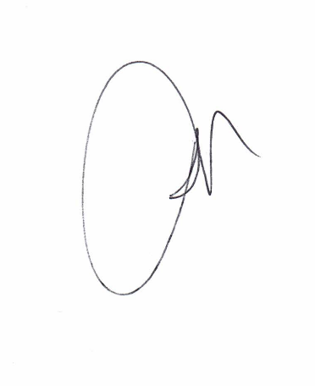 | Next Review Date: 02/01/2025

